1.TOPIC:GAMING CONSOLE

- INTRODUCTION

The gaming console is an electronic device or computer device. That outputs a video signal for visual images to display a video game that one or more people can play.
The first gaming console was invented by Ralph.H.Baer in 1970s but in 1972 magnavox release the world first home video game console.

Gaming consoles today like an Xbox or Sony play are all basically computers to play online games using a console gaming system, a person must create an online account.

hybrid console is a video game console that is designed to eat the to be used as home or a handle console.

the Nintendo which is classified based hybrid console because it can either connect to display without aid of another device or entire unit can be taken and played as a mobile platform. hybrid console is a video game console that is designed to eat the to be used as home or a handle console.

- the Nintendo which is classified based hybrid console because it can either connect to display without aid of another device or entire unit can be taken and played as a mobile platform.
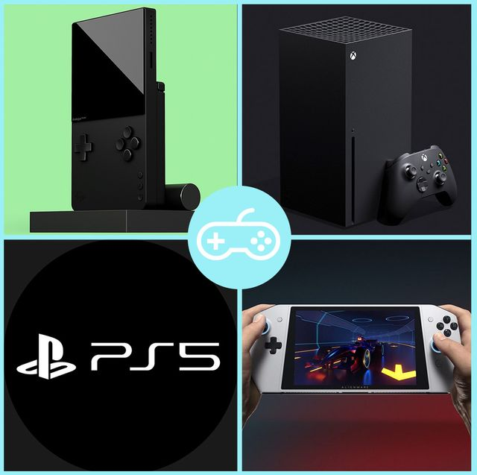
Figure 1: Insert your report image

  - Types of gaming console

:; Home console

:; Handheld console

:; Hybrid console

:; Home console

A home video game console is a video game console that is designed to be connected to and display device such as television and external power source as play video games

Home consoles are generally less powerful and customized at personal computer, design to have advanced graphic ability but limited memory and storage space to keep the unit affordable.

In 1972 Magnavox release first world home video game console the megavox odyssey

:; Handheld console

A handheld console are simply handheld console is a small, portable self contained video game console with suited in screen, game controls and speaker.

The first handle console with inter changeable cartridges is Milton Bradley Microvision in 1979.

Nintendo is credit with popularizing handheld console concept with release of gameboy in 1989 and continuous to dominate the Handheld console.

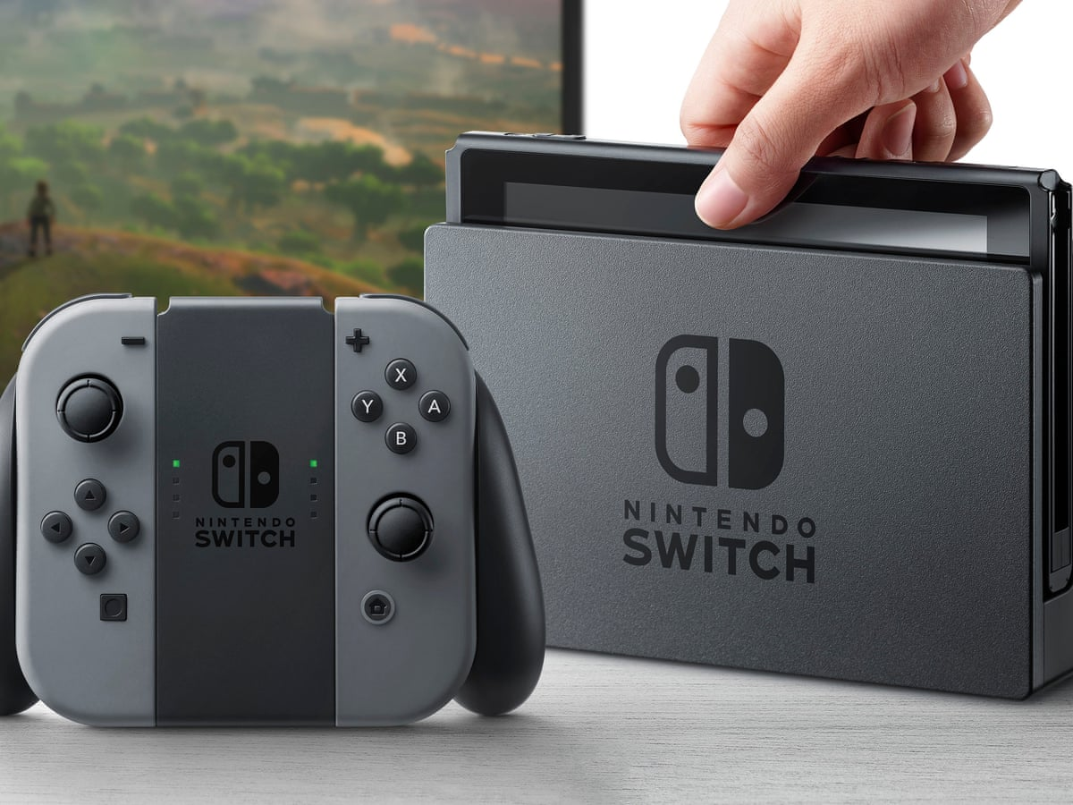
Figure 2: Insert Diagrams here

:; Hybrid console

Hybrid console is a video game console that is designed to eat the to be used as home or a handle console.

The Nintendo which is classified based hybrid console because it can either connect to display without aid of another device or entire unit can be taken and played as a mobile platform.

6. Summary and Future Work
Write your content here

References

- Jing, L., Ming, L., Bin, Y., Wenlong, L., A Novel Energy Efficient MAC Protocol for Wireless Body Area Network. China communication, Feb. 2015.
- Negra, R., Jemili, I., Belghith, A.: Wireless Body Area Networks: Applications and Technologies. Procedia Computer Science 83, 1274 – 1281 ( 2016 )
- Yuce, M.R.: Implementation of wireless body area networks for healthcare systems. In: Sensors and Actuators A: Physical, Vol 162, Issue 1, Pages 116-129. Elsevier B.V (2010)
- Dabhi, K., Mahet, A.: Internet of Nano Things-The Next Big Thing. In: International Journal of Engineering Science and Computing, vol 7 Issue No.4 (2017)
- Negra, R., Jemili, I., Belghith, A.: Wireless Body Area Networks: Applications and Technologies. Procedia Computer Science 83, 1274 – 1281 ( 2016 )
- Yuan, X., Li, C., Ye, Q., Zhan, K., Cheng, N., Zhan, N., Shen, X.: Performance Analysis of IEEE 802.15.6-Based Coexisting Mobile WBANs with Prioritized Trafﬁc and Dynamic Interference. In: IEEE Transactions on Wireless Communications (Volume: 17, Issue: 8, Aug. 2018)
- Adhikary S., Chattopadhyay S., Choudhury S.: A Novel Bio-inspired Algorithm for Increasing Throughput in Wireless Body Area Network (WBAN) by Mitigating Inter-WBAN Interference. In: Chaki R., Cortesi A., Saeed K., Chaki N. (eds) Advanced Computing and Systems for Security. Advances in Intelligent Systems and Computing, vol 667. Springer, Singapore (2018)
- Peng, H., Tian, Y., Kurths, J., Li, L., Yang, Y., Wang, D.: Secure and energy-efﬁcient data transmission system based on chaotic compressive sensing in body-to-body networks. IEEE Trans. Biomed. Circ. Syst. 11(3), 558–573 (2017)
- Samanta, A., Misra, S.: Energy-efﬁcient and distributed network management cost minimization in opportunistic wireless body area networks. IEEE Trans. Mobile Comput. 17, 376–389 (2017)
- Ahmad, S.S., Razzaque, M.A., Inmaculada T.R., Hussain, N.: IEEE 802.15.6 Standard in Wireless Body Area Networks From a Healthcare Point of View. The 22nd Asia-Pacific Conference on Communications (APCC2016)
- Yi, C., Wang, L., Li, Y.: Energy efﬁcient transmission approach for WBAN based on threshold distance. IEEE Sensors J. 15(9), 5133–5141 (2015)
- Misra, S., Moulik, S., Chao, H.-C.: A cooperative bargaining solution for priority-based data-rate tuning in a wireless body area network. IEEE Trans. Wirel. Commun. 14(5), 2769–2777 (2015)
- Walsh, M.J., Hayes, M.J.: Throughput rate control for an 802.15.4 wireless body area network using static and low order anti-windup techniques. In: Proc. Mediterranean Conf. Control Autom, pp.1–6 (2007)
- Eberhart, R., Kennedy, J.: A New Optimizer Using Particle Swarm Theory. Sixth International Symposium on Micro Machine and Human Science, 0-7803-2676-8/95
- Kalaiselvi, K., Suresh, G.R. & Ravi, V.: Genetic algorithm based sensor node classiﬁcations in wireless body area networks (WBAN). Cluster Comput (2018)
- Nadeem, Q., Javaid, N., Mohammad, S.N., Khan, M.Y., Gull, M.: SIMPLE: Stable Increased-throughput Multi-hop Protocol for Link Efﬁciency in Wireless Body Area Networks. 26, Jul. 2013.

